What is an ip address?
-An IP address is your device’s address on a network.
-There are IPv4 addresses, and IPv6 addresses
-IPv4 are more common.
-IP addresses are comprised of 4 octets, 8 bits each for a total of 32 bits
-Each octet is a number from 0-255
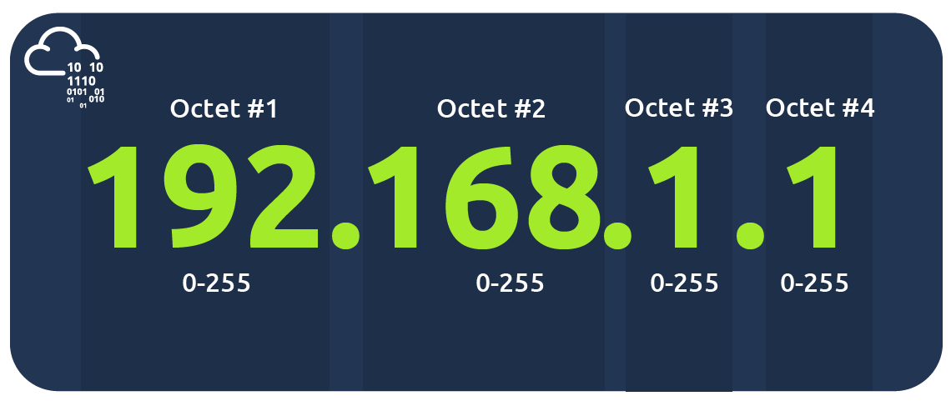
The 0 and 255 are usually reserved for the network and broadcast addresses, respectively. In other words, 192.168.1.0 is the network address, while 192.168.1.255 is the broadcast address. Sending to the broadcast address targets all the hosts on the network.

Public and Private IP addresses
-There are two types of IP addresses, public and private

Public IP Addresses
-Globally unique
-used to connect to websites, emails and other internet services

a subnet mask of 255.255.255.0 can also be written as /24. The /24 means that the leftmost 24 bits within the IP address do not change across the network, i.e., the subnet. In other words, the leftmost three octets are the same across the whole subnet; therefore, we can expect to find addresses that range from 192.168.66.1 to 192.168.66.254. Similar to what was mentioned earlier, 192.168.66.0 and 192.168.66.255 are the network and broadcast addresses, respectively.

You can look up your IP address on the MS Windows command line using the command ipconfig. On Linux and UNIX-based systems, you can issue the command ifconfig or ip address show, which can be typed as ip a s. In the terminal window below, we show ifconfig.

Private IP Addresses
-used within a local network
RFC 1918 defines the following three ranges of private IP addresses:
- 10.0.0.0 - 10.255.255.255 (10/8)
- 172.16.0.0 - 172.31.255.255 (172.16/12)
- 192.168.0.0 - 192.168.255.255 (192.168/16)

